**Lab 2 Part 2 Report**

**Title:** Find the Optimal Path for Dory

**Notice:** Dr. Bryan Runck

**Author:** Liang-Ting Chen

**Date:** Mar 4, 2021

**Project Repository:**

<https://github.com/chen6761/GIS5572>

**Abstract**

In the lab, I used the distance tool under the spatial analyst tools to figure an optimal that meets Dory’s different reference. I also took terrain, water, and road as consideration and improved the result. The report includes all the tools I executed and the steps I took.

**Problem Statement**

Dory wants to go fly fishing near the Whitewater State Park from her farm. This lab considers the terrain, river, surface land use, and her preference of route to find an optimal path for her.

|  |  |  |  |  |  |  |
| --- | --- | --- | --- | --- | --- | --- |
| **#** | **Requirement** | **Defined As** | **Spatial Data** | **Attribute Data** | **Dataset** | **Preparation** |
| 1 | Avoid the river without the bridge | Stream data from MN Geo | Stream geometry |  | [MN Geo](https://gisdata.mn.gov/dataset/env-impaired-streams-2012) |  |
| 2 | Walk on existing road | Road data from MN Geo | Road geometry |  | [MN Geo](https://gisdata.mn.gov/dataset/trans-roads-mndot-tis) |  |
| 3 | Avoid the steep surface | DEM data from MN Geo | DEM |  | [MN Geo](https://gisdata.mn.gov/dataset/elev-30m-digital-elevation-model) |  |
| 4 | Avoid the farm because muddy surface | Cropland data from MN Geo | Raster Data |  | [MN Geo](https://gisdata.mn.gov/dataset/agri-cropland-data-layer-2018) |  |

**Input Data**

In the lab, I follow the instructor to use .las files from Minnesota DNR and PRISM.

Table. The input data

|  |  |  |  |
| --- | --- | --- | --- |
| **#** | **Title** | **Purpose in Analysis** | **Link to Source** |
| 1 | DEM | Use as the surface and help to analyze the slope | [MN Geo](https://gisdata.mn.gov/dataset/elev-30m-digital-elevation-model) |
| 2 | Road | Use as a more suitable route | [MN Geo](https://gisdata.mn.gov/dataset/trans-roads-mndot-tis) |
| 3 | Cropland | Use to avoid the farm fields | [MN Geo](https://gisdata.mn.gov/dataset/agri-cropland-data-layer-2018) |
| 4 | Stream | Use as a barrier to avoid rivers | [MN Geo](https://gisdata.mn.gov/dataset/env-impaired-streams-2012) |

**Methods**

I used ArcPro to create three features, Start point, Destination point, and Boundary first, then changed the environment to the Jupyter Notebook. I imported all the input data above and used Clip Raster(arcpy.management.Clip), and Clip (arcpy.analysis.Clip) to leave only essential areas for the project (Figure 1 to 4).

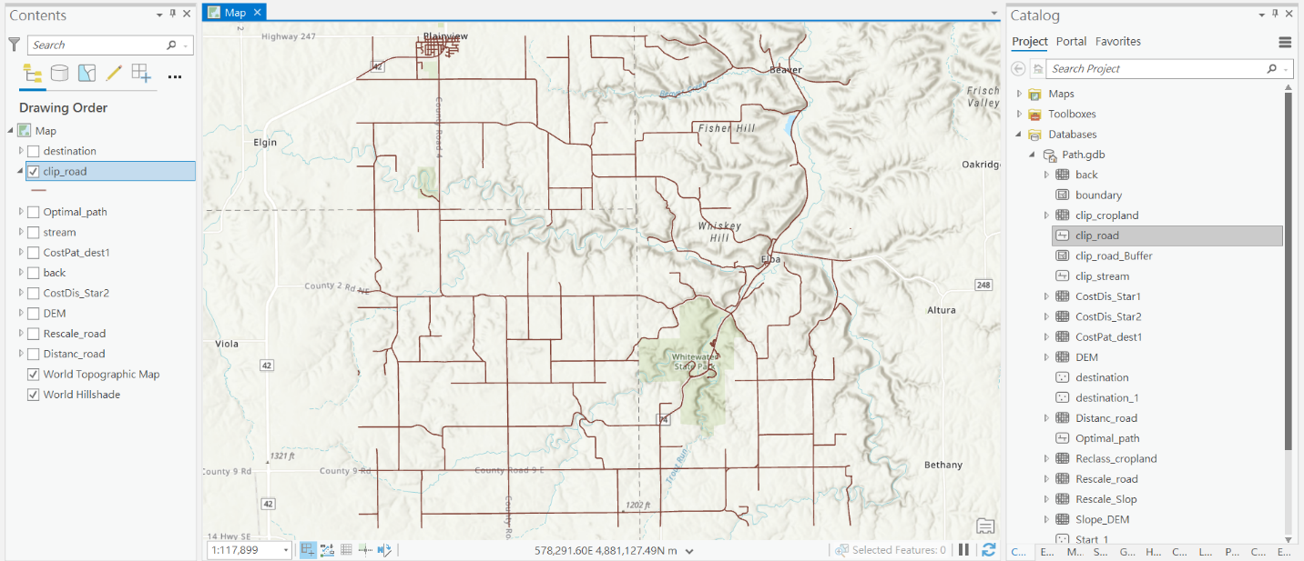

Figure 1. Clip Road Data

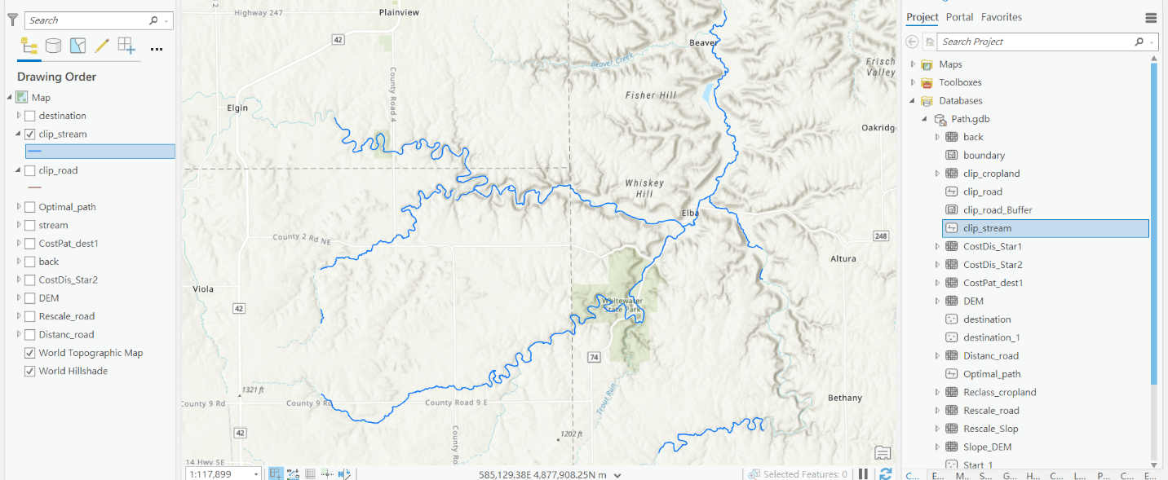

Figure 2. Clip Stream Data

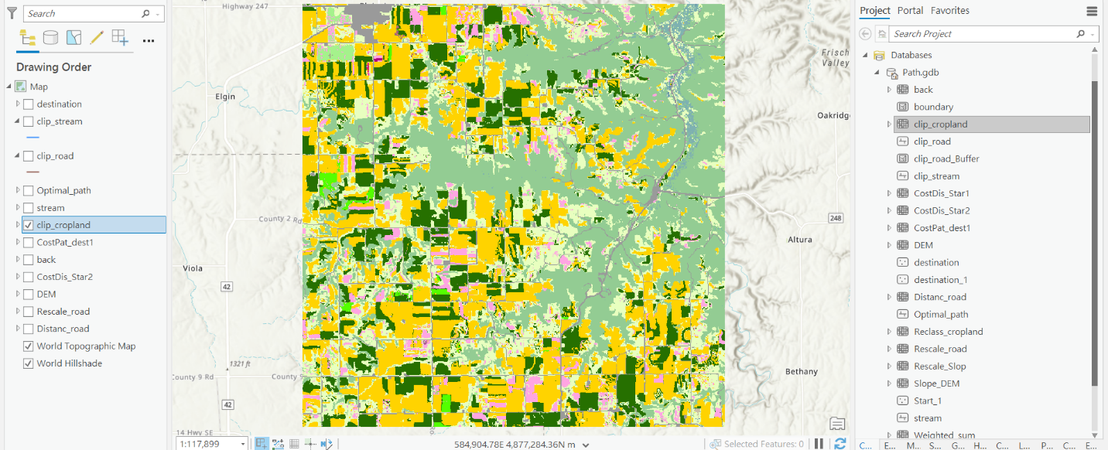

Figure 3. Clip Cropland Data

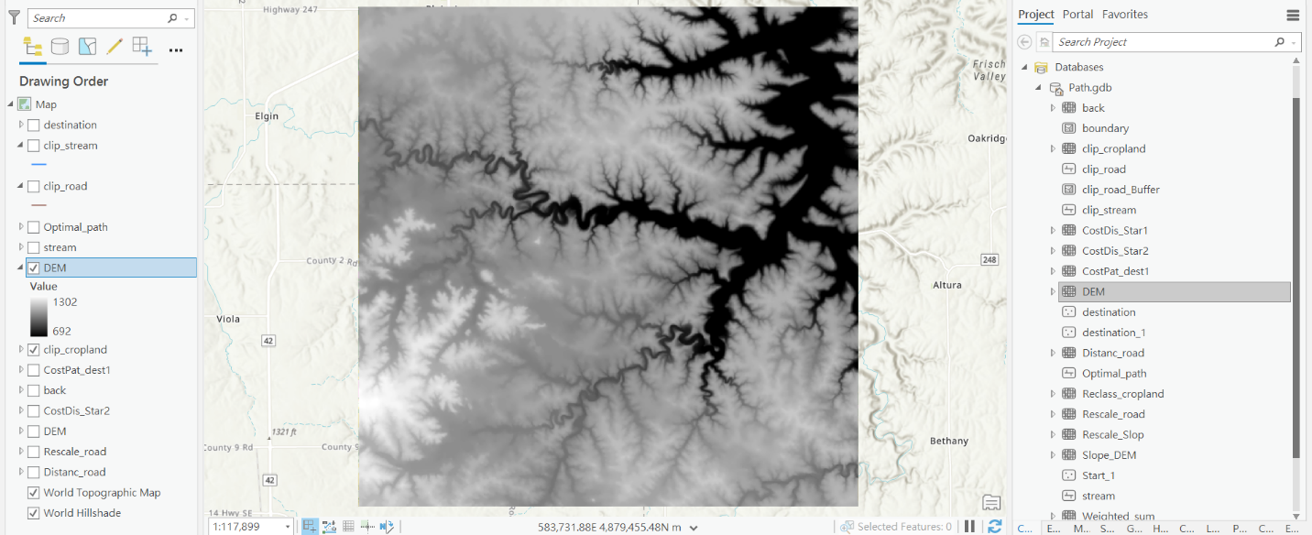

Figure 4. Clip DEM Data

In the lab, I did not use bridge data, instead of that, I buffered the road for 50 meters (arcpy.analysis.Buffer) and erased the stream data (arcpy.analysis.Erase) because their intersection stood for the bridges normally. (Figure 5)

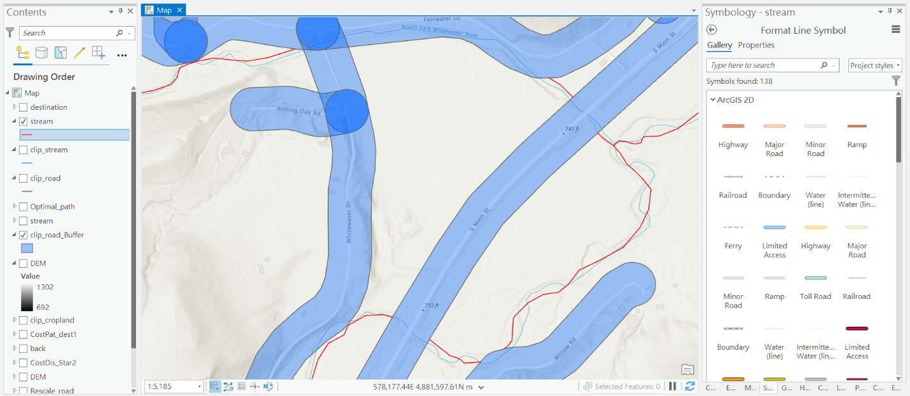

Figure 5. Erase Stream Data with Buffered Road Data

After cleaning up the data, I used the Distance Accumulation tool (arcpy.sa.DistanceAccumulation) and the Rescale by Function tool (arcpy.sa.RescaleByFunction) to get the cost surface of the Road. In this cost surface, the closer of roads represented the lower cost value. (Figure 6 and 7)

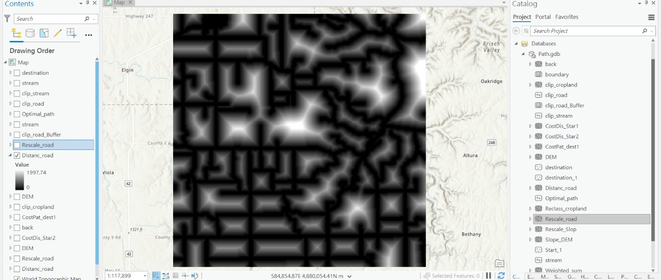

Figure 6. Distance Accumulation Output of Road Data

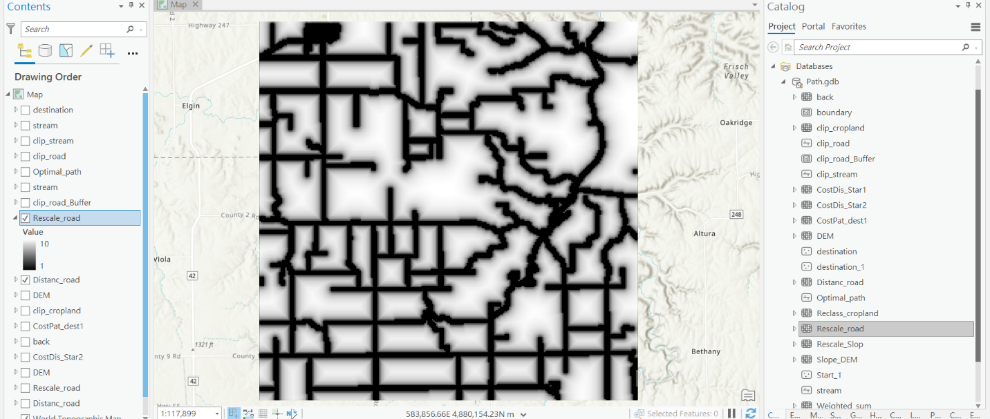

Figure 7. Rescale Output of Road Data

About the DEM data, I analyzed it with the Slope tool (arcpy.sa.Slope) first to get the distribution of the steep area. Then, I used the Rescale by Function tool (arcpy.sa.RescaleByFunction) to assign a higher value for the steeper area. (Figure 8 and 9)

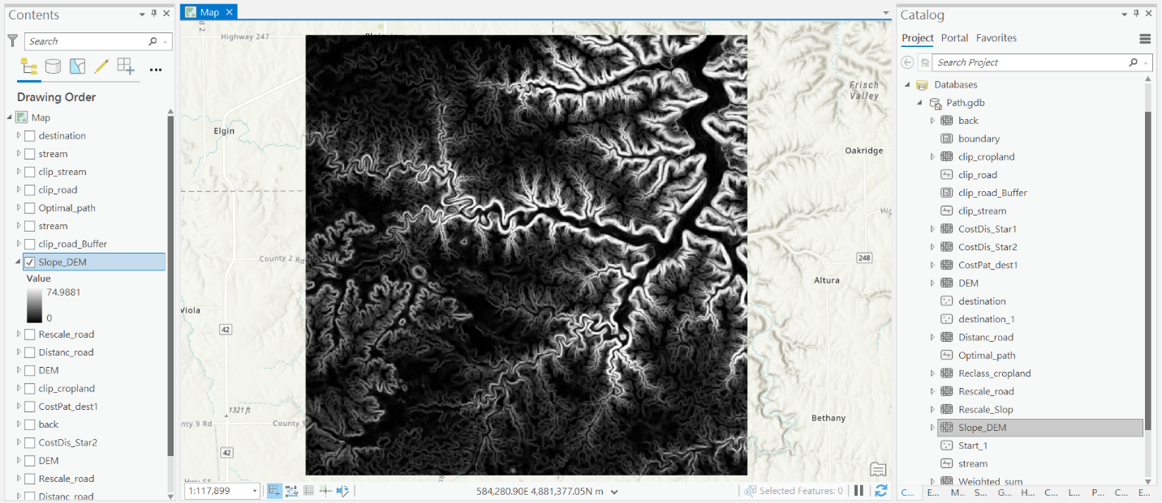Figure 8. Slope Output of DEM Data

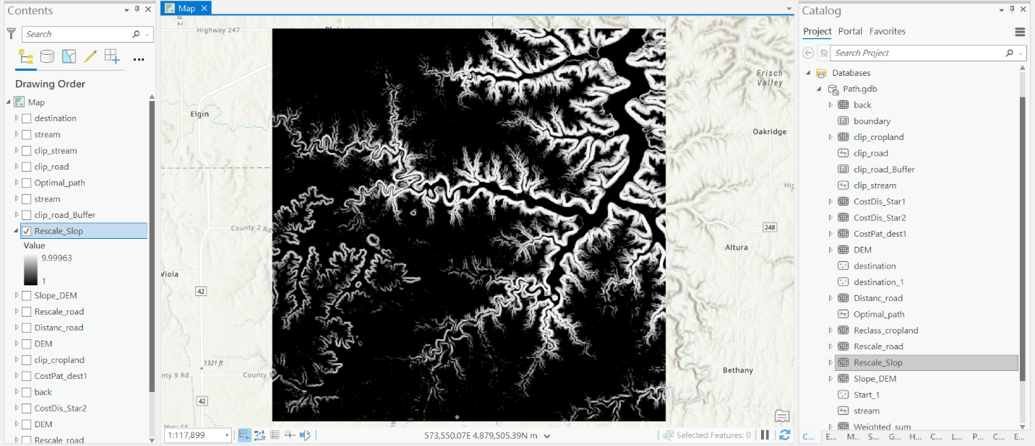

Figure 9. Rescale Output of DEM Data

I used the cropland data to create the last cost surface. I reclassified the data (arcpy.sa.Reclassify) to assign a higher cost value for the farm area and a lower value for the roads. (Figure 10) Then I executed the Weighted Sum tool (arcpy.sa.WeightedSum) to sum up all the cost surfaces, the values are presented between 3 to 30. (Figure 11)

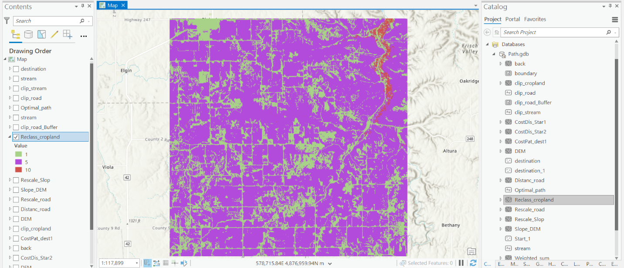

Figure 10. Reclassification Output of Cropland Data

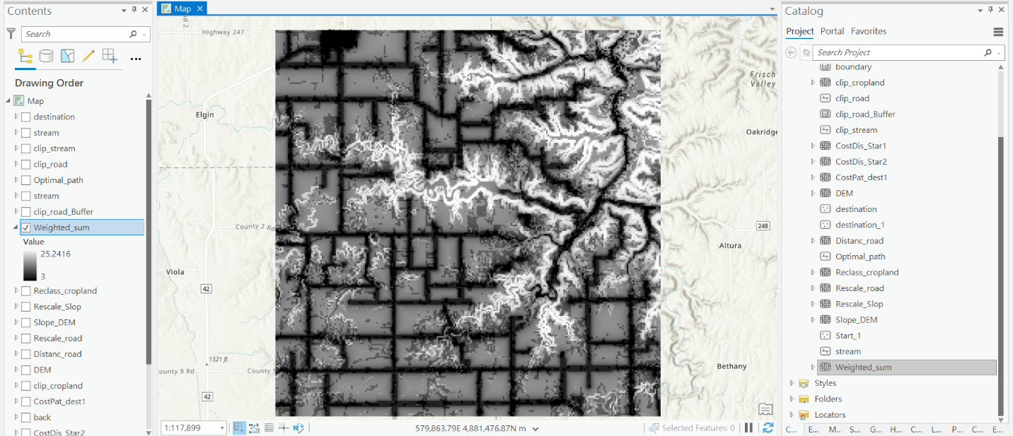

Figure 11. Weighted Sum Output

To get the optimal path, I had tried using the Optimal Path as Line tool but failed. The output only showed up a little path that directly pointed to the river. After I reviewed the Esri official demo again (Johnston et al., 2020), I tried the Optimal Region Connections and got a more reasonable route. In the demo, they tried to connect several bear habitats with the tool. Although I only had two points (Start and Destination) in the lab, it succeeded to showed up a good path for Dory.

**Results**

The final optimal output looks like this. It followed the road, seldom crossed the farm, avoided the steep slope, and connected the start/destination points. (Figure 12)

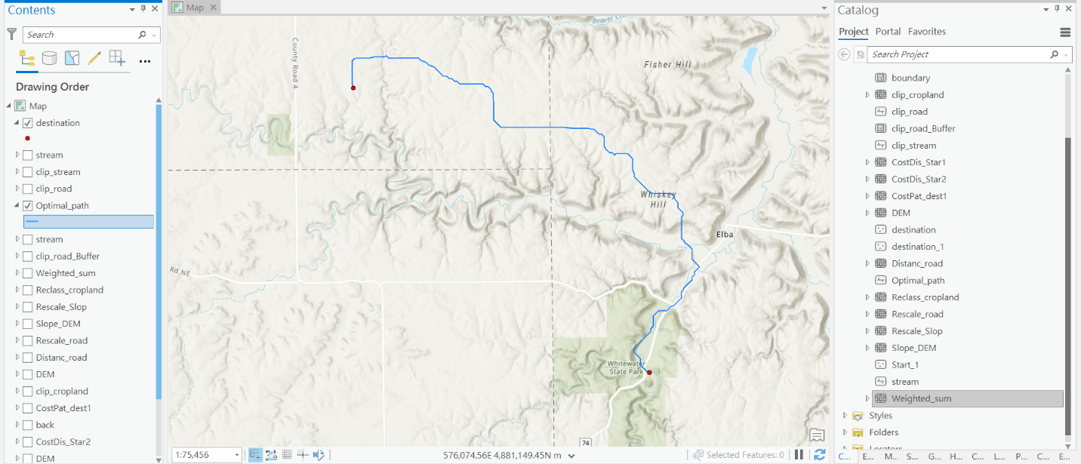

Figure 12. Optimal Path Output

**Results Verification**

To check my result, I used the method in week 5 slide 32. Instead of using the Optimal Region Connection tool, I analyzed the route with the Cost Distance and the Cost Path tool to see if I could have the same path.

I used the start point and the weighted sum data as the input to execute the Cost Distance tool. It came up with a distance raster (Figure 13) and a backlink raster (Figure 14) Then, I took both outputs above and the destination points as input to execute the Cost Path tool, and the optimal path showed up. (Figure 15)

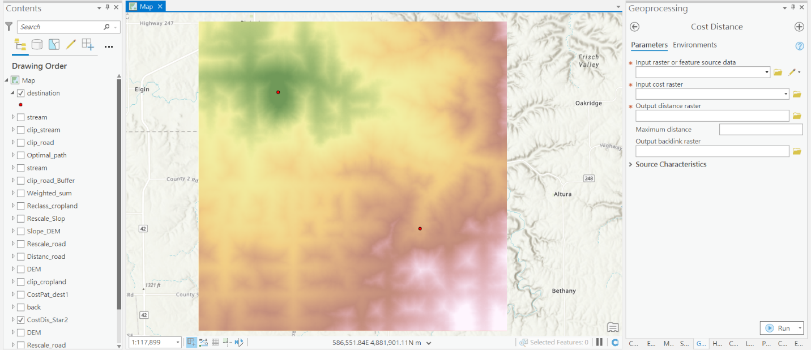

Figure 13. Distance Raster

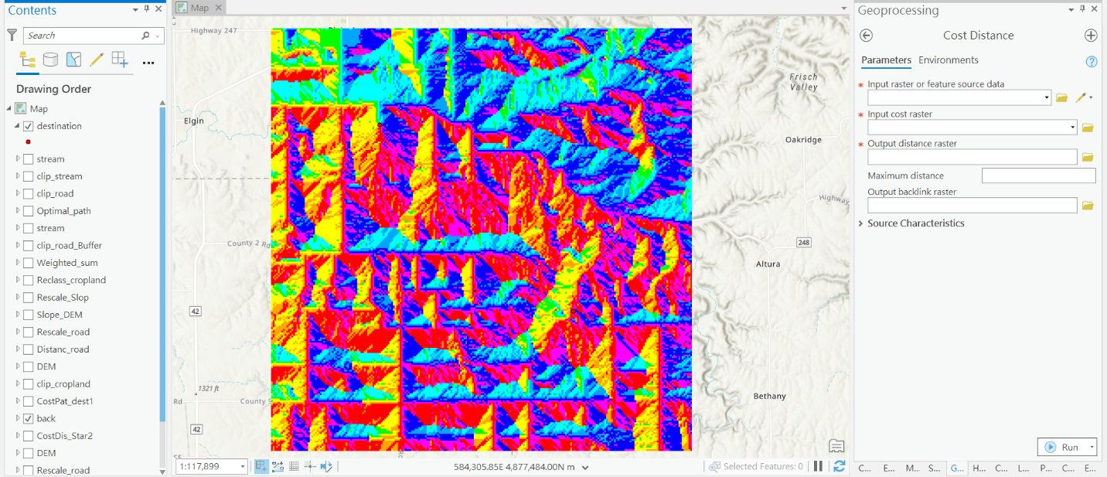

Figure 14. Backlink Raster

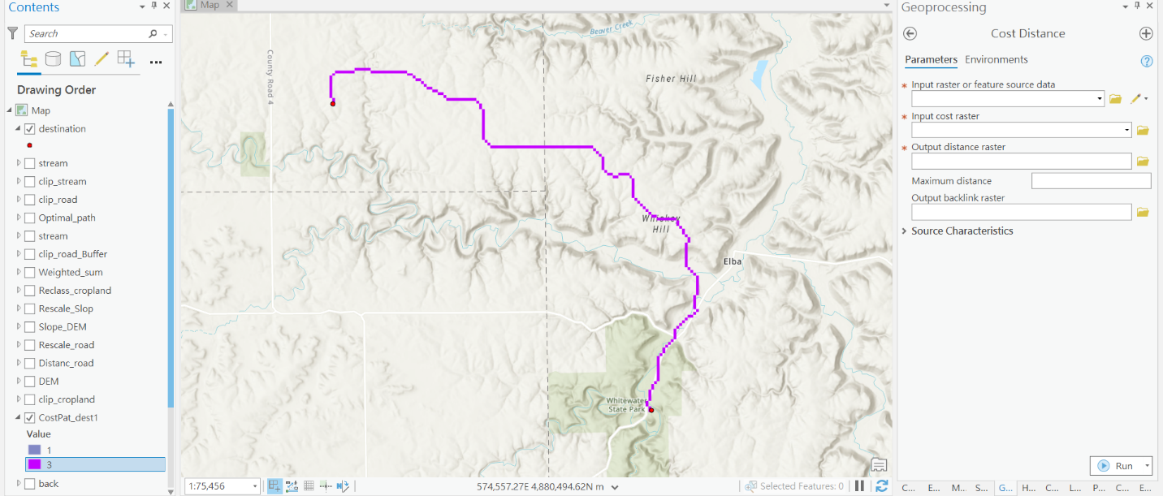

Figure 15. Cost Path Output

I compared two optimal paths and found they were similar, so I thought the output was correct. (Figure 16)

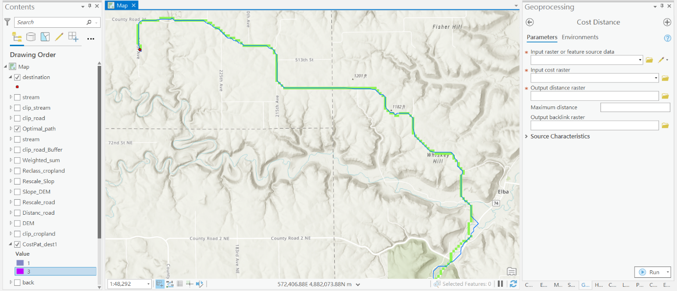

Figure 16. Two Optimal Path Output (Blue one came out with the Optimal Regions Connection tool; green one came out with the Cost Distance and Cost Path tool)

**Discussion and Conclusion**

In the lab, I learned that I could consider several issues that may influent the path output. I also can multiply the value by different coefficients according to the importance of each cost surface. Although I did not use the “Optimal Path as Line” tool, the output looked reasonable and it was a path that meets Dory’s reference. The distance toolset is powerful, and it is a useful one to solve the problem in the real life. I also wonder whether the google map uses a similar method to build up the best routes for users or not.

**References**

Johnston, K., Graham, E., & Tenbrink, J. (2020). Distance Analysis: Identifying Optimal Paths Using Rasters. Esri. https://www.esri.com/training/catalog/60109c7e8106ed0454f90b25/distance-analysis%3A-identifying-optimal-paths-using-rasters/#!/arcgis-online-training/

**Self-score**

|  |  |  |  |
| --- | --- | --- | --- |
| **Category** | **Description** | **Points Possible** | **Score** |
| **Structural Elements** | All elements of a lab report are included **(2 points each)**:  Title, Notice: Dr. Bryan Runck, Author, Project Repository, Date, Abstract, Problem Statement, Input Data w/ tables, Methods w/ Data, Flow Diagrams, Results, Results Verification, Discussion and Conclusion, References in common format, Self-score | 28 | 28 |
| **Clarity of Content** | Each element above is executed at a professional level so that someone can understand the goal, data, methods, results, and their validity and implications in a 5 minute reading at a cursory-level, and in a 30 minute meeting at a deep level **(12 points)**. There is a clear connection from data to results to discussion and conclusion **(12 points)**. | 24 | 22 |
| **Reproducibility** | Results are completely reproducible by someone with basic GIS training. There is no ambiguity in data flow or rationale for data operations. Every step is documented and justified. | 28 | 27 |
| **Verification** | Results are correct in that they have been verified in comparison to some standards. The standard is clearly stated **(10 points)**, the method of comparison is clearly stated **(5 points)**, and the result of verification is clearly stated **(5 points)**. | 20 | 19 |
|  |  | 100 | 96 |